Creating a new Pound Scheme

Contents

[Introduction 2](#_Toc150333738)

[Create new Scheme in Transactor\_Live UAT database 3](#_Toc150333739)

[UspSchemeDefaultInsert procedure 3](#_Toc150333740)

[Commissions 5](#_Toc150333741)

[Subagent commission splits 6](#_Toc150333742)

[Create WPD / calculator 7](#_Toc150333743)

[Identify whether old or new style Pound Scheme required 7](#_Toc150333744)

[Creating an old style Pound Scheme WPD 8](#_Toc150333745)

[Creating a new style Pound Scheme WPD and calculator 9](#_Toc150333746)

[Calculator steps 9](#_Toc150333747)

[WPD steps 10](#_Toc150333748)

[Test the Pound Scheme in TGSL 11](#_Toc150333749)

[Release to live TGSL 13](#_Toc150333750)

# Introduction

A Product (Line of Business) and an insurer together make a Scheme. For example, when quoting a prospective customer for a Tradesman Liability policy (this is the Product) in TGSL, results will be returned for multiple insurers. Each of these is a separate Scheme:

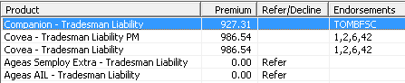

In a regular Scheme, a calculator processes the risk information against the rules and rates provided by each insurer to return the quoted premium. However, there are also Schemes that do not fully calculate a premium. These are set up quickly so that Moorhouse can sell policies for a new insurer. They return a nominal premium of £1 (hence the name “Pound Scheme”) that the underwriters can then manually update to a real amount.

When quoting in TGSL, Pound Schemes will always refer. By double-clicking on a referred Pound Scheme a message similar to the below will be displayed:

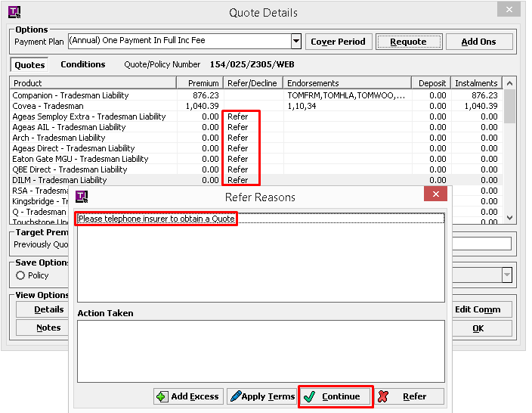

By clicking the **Continue** button outlined above, the £1 premium will be applied (plus admin fee and IPT).

# Create new Pound Scheme in UAT

## UspSchemeDefaultInsert procedure

1. Launch SQL Server management Studio and connect to **MHGSQL01\TGSLTEST** (UAT):  
   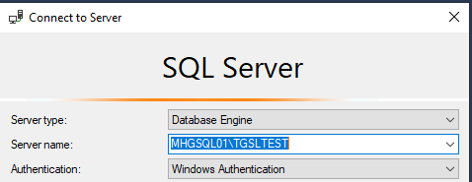
2. Click on the **New Query** button on the toolbar:  
   
3. Select the **Transactor\_Live** database from the dropdown:  
   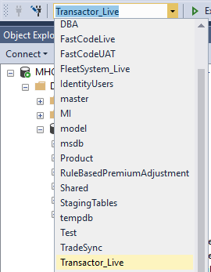
4. Copy and paste the following SQL script into the new query window but do not run it yet:

DECLARE

@SchemeName nvarchar(255) = 'Towergate - Professional Indemnity'

,@SchemeFileName nvarchar(12) = 'TOWPI001.wpd'

,@ProductTypeID int = 209

,@InsurerID varchar(50) = '228'

,@NetRated bit = 0

,@InternetAvailable bit = 1

,@ParameterGroupName varchar(255) = 'Commercial Scheme Parameters'

,@RangeGroupName varchar(255) -- NULL - procedure will create new

,@CommissionGroupName varchar(255) -- NULL - procedure will create new

,@RangePrefix char(5) = 'TOWPI'

,@ErrorText varchar(4000) = ''

,@AgentID varchar(MAX) = '5208F39A498E4706A91BEEC84ED25686,E2F376B621E14C1FB532CED74C7EDCE1,0F849A389DD4477CAF66BBCBECA49AA4,83512274B9F14EBF9B4F81DE2591EC80' -- Constructaquote.com, Constructaquote, XBroker, Moorhouse

EXEC [dbo].[uspSchemeDefaultInsert]

@SchemeName

,@SchemeFileName

,@ProductTypeID

,@InsurerID

,@NetRated

,@InternetAvailable

,@ParameterGroupName

,@RangeGroupName

,@CommissionGroupName

,@RangePrefix

,@ErrorText OUTPUT

,@AgentID

SELECT @ErrorText

GO

1. Amend the values highlighted in yellow above with the relevant values as follows:
   1. **@SchemeName**: Run the following query:  
      SELECT \* FROM RM\_SCHEME WHERE NAME LIKE 'Towerg%'   
      Change the insurer name as required. This list will give you an idea of how the insurer’s other products are named/labelled so you can copy the same format for the new Scheme:

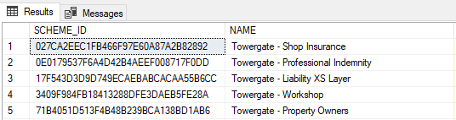

* 1. **@SchemeFileName**: This will be the file name for the WPD file. It is usually the same as @RangePrefix (the format for the policy numbers that will be created), which may have been specified on the ticket. If not, run the following query:   
     SELECT \* FROM SYSTEM\_SCHEME\_DEFINITIONS WHERE PRODUCTNAME LIKE 'Towerg%'  
     Change the insurer name as required. This will show the names of the existing WPD files, usually made up of a three letters of the insurer name, two or three letters for the Product, and a sequential number. You can use a similar format for the new Scheme:  
     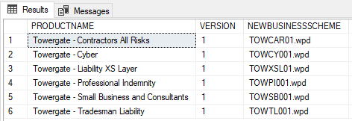
  2. **@ProductTypeID**: Run the following query:   
     SELECT \* FROM RM\_PRODUCT WHERE NAME like 'Professional%'  
     Change the product name as required. Get the ID from the PRODUCTTYPE\_ID column in the results:  
     
  3. **@InsurerID**: Run the following query:  
     SELECT \* FROM RM\_SCHEME WHERE NAME LIKE 'Towerg%' ORDER BY NAME

Change the insurer name as required. Compare the INSURER\_ID column for the insurer’s existing schemes. If they are all the same, then this is the ID to use. There may be different Insurer IDs as in the following example where there are records for “Towergate” and “Towergate Underwriting Agency”. If it is not clear from the specification or ticket which one should be used then check with Operations, or whoever raised the ticket.

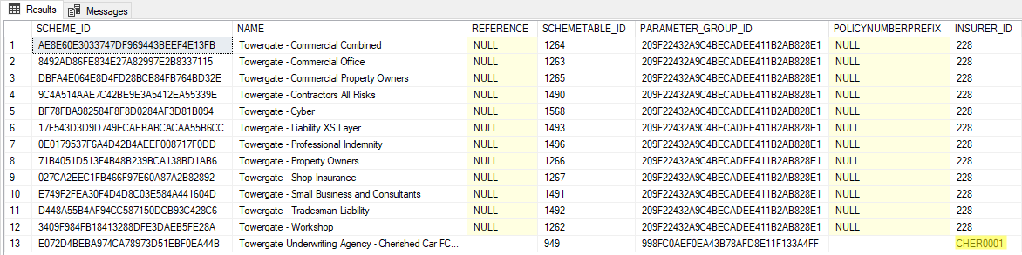

* 1. **@RangePrefix**: This is a five character field that will drive the format for the policy numbers that will be created, and may have been specified on the ticket. If not, it is usually made up of a three letters of the insurer name, and two or three letters for the Product. It is also usually the same as the first five characters of the WPD file name (see the @SchemeFileName step above).
  2. **@AgentID**: This is a comma separated list of the Agent IDs that the Scheme needs to link to. These should be specified on the ticket and will commonly be Constructaquote, Constructaquote.com, and Moorhouse, plus XBroker if applicable. The Agent IDs are the primary key from the RM\_Agent table in the Transactor\_Live database.

1. Save the script in a new subfolder in the following location:   
   L:\Public\IT\Development\Tickets\Monday  
   The new subfolder can be named with the ticket number from the Monday.com board. The script will be used later for the live release.
2. Execute this script in the UAT database (Transactor\_Live on MHGSQL01\TGSLTEST) and you'll see the results similar to below:  
   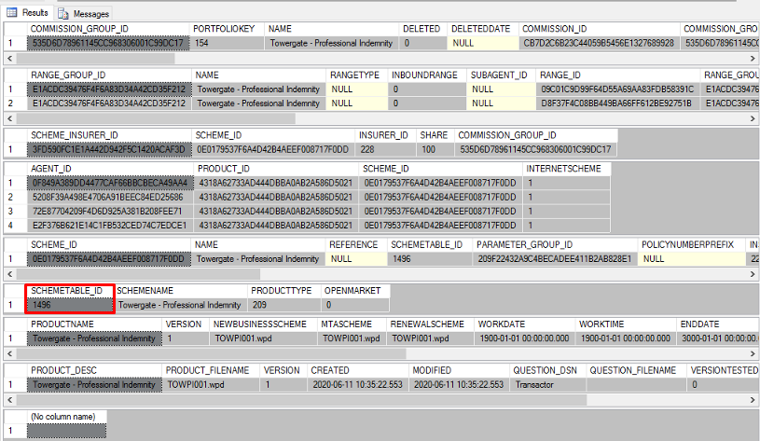
3. Make a note of the new SCHEMETABLE\_ID that has been created (outlined in red above) as you will need it for the following steps.

## Commissions

1. Copy the following update statement and paste it at the end of the release script saved above but do not run it yet:

UPDATE

[C]

SET

[C].[NB\_Partner\_Percent] = 20

,[C].[MTA\_Partner\_Percent] = 20

,[C].[REN\_Partner\_Percent] = 20

FROM

[dbo].[RM\_Commission\_Group] AS [CG]

JOIN [dbo].[RM\_COMMISSION] AS [C] ON [C].[COMMISSION\_GROUP\_ID] = [CG].[COMMISSION\_GROUP\_ID]

WHERE

[CG].[Name] = 'Towergate - Professional Indemnity'

GO

1. Amend the values highlighted in yellow above with the relevant values as follows:
   1. The percentages should be provided in the ticket on the Monday.com board. If not, reply to the person who raised the ticket.  
      Note, NB is new business, MTA is mid-term adjustment and REN is renewal. The percentages will usually be the same.  
      If the commission is to be split with subagents (e.g. via XBroker), the figures above need to be the totals. For example, if the split is 11% to Moorhouse and 15% to the subagent, then the total 26% should be entered here.
   2. Change the insurer name so that it exactly matches the wording used for @SchemeName earlier in the script.
2. Save the changes to the script. The script will be used later for the live release.
3. Execute the update in the UAT database (Transactor\_Live on MHGSQL01\TGSLTEST).

## Subagent commission splits

**If there is no subagent commission split then ignore this section and proceed to** [**creating the WPD / calculator**](#_Create_WPD_/).

1. If the commission is to be split with subagents (e.g. via XBroker), an additional row needs to be inserted into the RM\_COMMISSION table. Copy the following script and paste it at the end of the release script saved above but do not run it yet:

DECLARE @CommissionGroupID char(32)

,@PARTNER\_PERCENT float

,@AGENT\_PERCENT float

,@SUBAGENT\_PERCENT float

,@AGENT\_ID char(32)

SET @CommissionGroupID = (SELECT [COMMISSION\_GROUP\_ID] FROM [dbo].[RM\_COMMISSION\_GROUP] WHERE [NAME] = 'Towergate - Professional Indemnity')

SET @PARTNER\_PERCENT = 11

SET @AGENT\_PERCENT = 0

SET @SUBAGENT\_PERCENT = 15

SET @AGENT\_ID = '0F849A389DD4477CAF66BBCBECA49AA4' -- XBroker

INSERT INTO [dbo].[RM\_COMMISSION]([COMMISSION\_ID], [COMMISSION\_GROUP\_ID], [AGENT\_ID], [SUBAGENT\_ID], [EFFECTIVEDATE], [COMMISSIONLIMIT], [NB\_PARTNER\_PERCENT], [NB\_PARTNER\_FLAT], [NB\_AGENT\_PERCENT], [NB\_AGENT\_FLAT], [NB\_SUBAGENT\_PERCENT], [NB\_SUBAGENT\_FLAT], [MTA\_PARTNER\_PERCENT], [MTA\_PARTNER\_FLAT], [MTA\_AGENT\_PERCENT], [MTA\_AGENT\_FLAT], [MTA\_SUBAGENT\_PERCENT], [MTA\_SUBAGENT\_FLAT], [REN\_PARTNER\_PERCENT], [REN\_PARTNER\_FLAT], [REN\_AGENT\_PERCENT], [REN\_AGENT\_FLAT], [REN\_SUBAGENT\_PERCENT], [REN\_SUBAGENT\_FLAT], [PARTNER\_DISCOUNT], [AGENT\_DISCOUNT], [SUBAGENT\_DISCOUNT], [EXPIRYDATE], [ANYSUBAGENT])

VALUES (REPLACE(NEWID() , '-' ,'') ,@CommissionGroupID ,@AGENT\_ID ,NULL ,'2020-06-20 00:00:00',0,@PARTNER\_PERCENT,0,@AGENT\_PERCENT,0,@SUBAGENT\_PERCENT,0,@PARTNER\_PERCENT,0,@AGENT\_PERCENT,0,@SUBAGENT\_PERCENT,0,@PARTNER\_PERCENT,0,@AGENT\_PERCENT,0,@SUBAGENT\_PERCENT,0,0,0,0,'3000-01-01 00:00:00' ,1)

1. Amend the values highlighted in yellow above with the relevant values as follows:
   1. Change the insurer name so that it exactly matches the wording used for @SchemeName earlier in the script. This will pick up the COMMISSION\_GROUP\_ID that was generated by the stored procedure run. Do not hard code the ID here, as it will change on live release.
   2. The percentages will have been provided in the ticket on the Monday.com board if split commission has been specified. The partner percentage is the Moorhouse commission, and the subagent percentage is the sub-broker commission. The agent percentage is usually zero.
   3. @AGENT\_ID will almost always remain the same as above, for XBroker, unless some other kind of split has been specified on the ticket.
2. Save the changes to the script. The script will be used later for the live release.
3. Execute the insert in the UAT database (Transactor\_Live on MHGSQL01\TGSLTEST).

# Create WPD / calculator

## Identify whether old or new style Pound Scheme required

Historically, the calculator logic has been built into files called WPDs (the file extension is .wpd) with calculations written in TGSL’s proprietary TCAS calculator language. This is an extremely verbose language which is difficult to code, read, and debug.

New style schemes still require a WPD file to interface with TGSL. However, a standard file is now created which acts as little more than a link, providing the risk information to SQL procedures, functions and views. For a full explanation of the difference between old and new style calculators, see the “Creating a new Scheme” documentation.

Pound Schemes can be created in the new format so long as at least one calculator already exists for the same Product, otherwise the Product level objects will not yet exist to support a new style Pound Scheme.

1. Still within SQL Server management Studio connected to **MHGSQL01\**TGSLTEST, expand the **Calculators** database and then filter the TVF list by expanding the **Programmability** folder, **Functions** subfolder, and right-clicking on **Table-valued Functions**, then selecting **Filter** and **Filter Settings**:  
   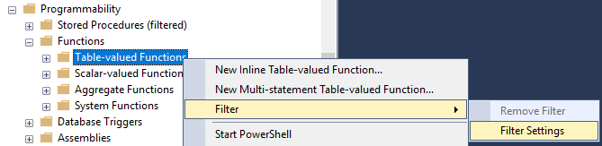
2. Enter a filter for Name contains “tvfSchemeDispatcher”:  
   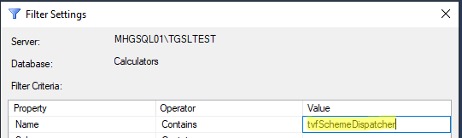
3. Click **OK**
4. Expand the filtered TVF folder to see all the functions that match the filter:  
   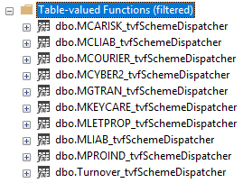
5. Identify whether a function exists for the Product code of the Product you need to create a Pound Scheme for. For example, if you need to create a Pound Scheme for the Tradesman Liability Product you can see that a function already exists for the MLIAB Product code. (If unsure of the Product code for your Product, look up the PRODUCTTYPE\_ID in the RM\_PRODUCT table in the Transactor\_Live database, then query the SYSTEM\_LIST\_PRODUCTTYPE\_ALIAS table for this ID.)

|  |
| --- |
| **If the Product already has a new style calculator, follow the instructions for** [**Creating a new style Pound Scheme**](#_Creating_an_new) **below.**  **If the Product does NOT already have a new style calculator, follow the instructions for** [**Creating an old style Pound Scheme**](#_Creating_an_old) **below.** |

## Creating an old style Pound Scheme WPD

Old style Pound Scheme WPDs contain the logic within the WPD syntax in the file. These will return £1 premiums to TGSL for each of the premium sections / coverages that are relevant to the Product. Therefore, the easiest way to create a new Pound Scheme WPD is to copy an existing one for the same Product.

1. Launch File Explorer and navigate to L:\TCAS\Schemefiles
2. Locate an existing WPD Pound Scheme file for the same Product. Some examples of files you can copy are as follows:

|  |  |
| --- | --- |
| **Line of business** | **Pound scheme file** |
| Contractors All Risks | DILCAR01.wpd |
| Liability XS Layer | DILXSL01.wpd |
| Professional Indemnity | DILPI001.wpd |
| Small Business & Consultants | DILSB001.wpd |
| Tradesman Liability | DILTL001.wpd |
| Turnover | DILTO001.wpd |

If the Product you need is not listed above, you can identify a Pound Scheme by looking for the Product code as the fourth and fifth characters of the file name. Open these files in a text editor and look for one that has no "ApplyTable" command in it. This indicates it is not selecting from any database tables or calling any stored procedures. It should also end with an unconditional refer for all quotes and the end of the file, e.g.:

{Refer}Refer  
{TypeString}Please telephone insurer to obtain a Quote  
{End Refer}End Refer

1. Copy and paste the WPD file into the ticket folder created earlier in L:\Public\IT\Development\Tickets\Monday
2. Rename the copied file with the filename entered for the @SchemeFileName parameter when creating the scheme.
3. Open the copied and renamed file in a text editor such as Notepad++ and amend the following:

|  |  |
| --- | --- |
| **TIP:** To make working with WPD files easier, you can use a user defined language in Notepad++ to change the colour of keywords and comments. In Notepad++ click on **Language > User Defined Language > Define your language…** In the window the opens, click **Import** and load the file GIT\TGSL\LineOfBusiness\Tools\WPD user defined language for Notepad++.xml. Then, after opening a WPD file in Notepad++, click on **Language** and select **WPD**. |  |

* 1. After the {SchemeName} tag, change the Scheme name to match the value used for the @SchemeName parameter when creating the Scheme (i.e. the Product and insurer). Note, the name used here can differ from the name on the Scheme record if required. The name in the WPD is the name that will be displayed on the quote panel in TGSL.
  2. After the {Underwriter} tag, change the name to the insurer of the new scheme.
  3. Update the highlighted values in the comments near the top of the file:

Author: Martin Clements

Filename: DILPI001.wpd

Create date: 30-01-2019

* 1. Search for a section that contains “SchemeTableID%” (as below). If it exists (it doesn't seem to be always required), change the highlighted value to the ID of the new scheme:

{Equation}Equation

{TypeWorkfield}SchemeTableID%

{Operator=}=

{TypeConstant}1485

{End Equation}End Equation  
The SCHEMETABLE\_ID can be found using the following query (changing the name as required):  
SELECT \* FROM RM\_SCHEME WHERE NAME LIKE 'Towerg%'

1. Save the changes and close the file.
2. Copy the new WPD into L:\Test\TCAS\Schemefiles
3. Proceed to the [Test the Pound Scheme in TGSL](#_Test_the_Pound) section

## Creating a new style Pound Scheme WPD and calculator

### Calculator steps

1. Follow the instructions in the [Identify whether old or new style Pound Scheme required](#_Identify_whether_old) section above to locate the <Product Code>\_tvfSchmeDispatcher function for the relevant Product in the Calculators database on MHGSQL01\TGSLTEST
2. Right-click on the function and select **Modify**:  
   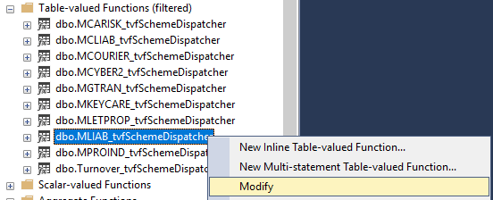
3. The TVF script will open in a new query window. Scroll down to the end to locate the “Refer Scheme” section that refers Pound Schemes with an ‘Automatic Referral’ message:  
   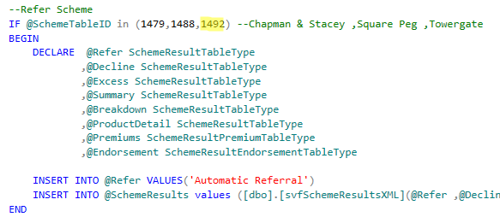
   1. If this section is commented out due to the Product having no previous Pound Schemes, uncomment it.
   2. Add the SCHEMETABLE\_ID into the list of IDs in brackets where highlighted above. The SCHEMETABLE\_ID can be found using the following query (changing the name as required):  
      SELECT \* FROM RM\_SCHEME WHERE NAME LIKE 'Towerg%'

Note, that you may see differences in how the £1 premiums are set. Some Products set the premium to £1 here in the tvfSchemeDispatcher, e.g.:  
  
Whereas other Products may set the premiums to zero here, or be missing this line entirely, meaning the premiums are NULL. The <Product code>\_uspCalculator stored procedure then sets NULL or zero premiums to £1 for all referrals. These can be left to continue functioning according to the current logic.

1. Save the script in the ticket folder created earlier in L:\Public\IT\Development\Tickets\Monday. The script will be used later for the live release.
2. Execute the ALTER FUNCTION script in the UAT database (Transactor\_Live on MHGSQL01\TGSLTEST).

### WPD steps

New style Pound Scheme WPDs contain the default logic that passes risk XML to the calculator and receives the output. Therefore, any new style WPD for the same Product can be copied (assuming it uses the default number of inputs and outputs).

1. Launch File Explorer and navigate to L:\TCAS\Schemefiles
2. Locate an existing new style WPD for the same Product. You can identify a Pound Scheme by looking for the Product code as the fourth and fifth characters of the file name. Open these files in a text editor and look for one that has an ApplyTable call to Calculators.dbo.<Product Code>\_uspCalculator, e.g.:  
   
3. Copy and paste the WPD file into the ticket folder created earlier in L:\Public\IT\Development\Tickets\Monday
4. Rename the copied file with the filename entered for the @SchemeFileName parameter when creating the scheme.
5. Open the copied and renamed file in a text editor such as Notepad++ and amend the following;
   1. After the {SchemeName} tag, change the Scheme name to match the value used for the @SchemeName parameter when creating the Scheme (i.e. the Product and insurer). Note, the name used here can differ from the name on the Scheme record if required. The name in the WPD is the name that will be displayed on the quote panel in TGSL.
   2. After the {Underwriter} tag, change the name to the insurer of the new scheme.
   3. Update the highlighted values in the comments near the top of the file:

Author: D. Hostler

Filename: TOWTL01.wpd

Create date: 15 Jan 2020

Version: 1.0

Description: Pound Scheme Towergate - Tradesman Liability

* 1. Just below the header, change the section that contains “SchemeTableID%” to the ID of the new scheme:

{Equation}Equation

{TypeWorkfield}SchemeTableID%

{Operator=}=

{TypeConstant}1485

{End Equation}End Equation  
The SCHEMETABLE\_ID can be found using the following query (changing the name as required):  
SELECT \* FROM RM\_SCHEME WHERE NAME LIKE 'Towerg%'

1. Save the changes and close the file.
2. Copy the new WPD into L:\Test\TCAS\Schemefiles

# Test the Pound Scheme in TGSL

1. Launch a remote desktop connection to MHGTGSL01Test
2. Click the start button and search for Services, then click to open:  
   
3. Scroll down to the **Transactor Relationship Manager** service, right-click it and choose **Restart**:   
   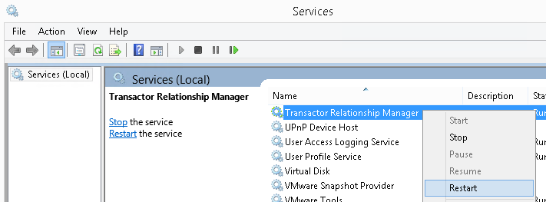  
   A window will appear showing the restart progress, and disappear when completed.
4. Click the start button and search for TCAS, then click to open:  
   
5. Log in
6. Perform an enquiry to find a suitable test customer:  
   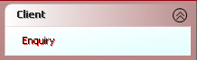

Client Search 
Search By 
O 
Policy/Quote Number 
Surname and/or Postcode 
• 
O 
Surname and Renewal Date 
O 
Surname and Date of Birth 
O 
Registration Number 
O 
Invoice Number 
O 
Client Reference 
O 
Company Name and/or Postcode 
O 
Insurer Policy Number 
O 
Claim Number 
O 
Telephone Campaign 
Sumame/Co_ Name Clements 
Postcode CFB3 2RA 
Cancel 

1. Once you've found a client then click **Policies**. If you already have a Policy Type for the appropriate Product click **Amend** and skip the next two steps. Otherwise click **Add Quote**:  
   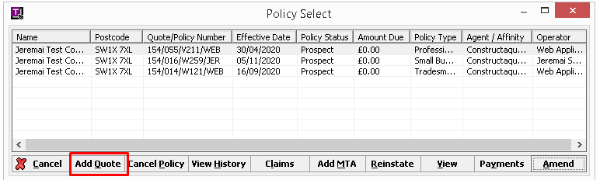
2. Select the Agent and Product from the Product Selection screen and click **OK**.
3. Fill in the quote screens, clicking **OK** or **Next** to progress through the screens.
4. Upon reaching the User Summary screen, click **Quote** and then **OK**.
5. The new Pound Scheme should appear in the list of quotes with ‘Refer’ shown in the Refer/Decline outcome column:  
   Quote Details 
   Conditions 
   Quotes 
   Product 
   Options 
   payment plan Annual Instalments Excluding CV & PC (20% Deposit) inc Coyer Period 
   129.88 
   Quotelpolicy Number 154/010/W147/MAR 
   Freelancer - Professional Indemnity 
   Fusion - Professional Indemnity 
   Hiscox - Professional Indemnity 
   HSBC - Professional Indemnity 
   Markel - Professional Indemnity 
   Miles Smith - Professional Indemnity 
   QBE - Professional Indemnity 
   QBE Direct - Professional Indemnity 
   RSA - Professional Indemnity 
   Tokjo Marine HCC - Professional Indemnity 
   Tokjo Marine HCC Open Market - Professio. 
   Toweraate - Professional Indemnit 
   Target Premium 
   Previously Quoted Premium 
   Premium 
   0.00 
   0.00 
   0.00 
   0.00 
   0.00 
   0.00 
   0.00 
   0.00 
   0.00 
   0.00 
   Refer Decline Endorsements 
   Refer 
   Refer 
   Refer 
   Refer 
   Refer 
   Decline 
   Refer 
   Refer 
   Refer 
   Refer 
   De osit 
   0.00 
   0.00 
   0.00 
   0.00 
   0.00 
   0.00 
   0.00 
   0.00 
   0.00 
   0.00 
   Difference % 
   Instalments 
   0.00 
   0.00 
   0.00 
   0.00 
   0.00 
   0.00 
   0.00 
   0.00 
   0.00 
   0.00 
   Save Options 
   O 
   View Options 
   Details 
   • 
   Prospect 
   Selected Premium 
   O 
   Client Decline 
   Breakdown 
   Endorsements 
   payment 
   Product Options 
   Discount 
   Edit Premium Edit Comm 

Double-click this row and ensure that the refer message appears:  
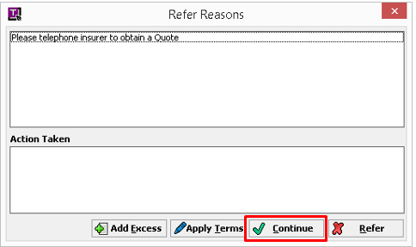

1. Click the **Continue** button outlined above. The small premium should now show in the Premium column:  
   Quote Details 
   Options 
   payment plan Annual Instalments Excluding CV & PC (20% Deposit) inc Coyer Period 
   Conditions 
   Quotes 
   Product 
   Quotelpolicy Number 154/010/W147/MAR 
   Fusion - Professional Indemnity 
   Hiscox - Professional Indemnity 
   HSBC - Professional Indemnity 
   Markel - Professional Indemnity 
   Miles Smith - Professional Indemnity 
   QBE Direct - Professional Indemnity 
   RSA - Professional Indemnity 
   Tokjo Marine HCC - Professional Indemnity 
   Tokjo Marine HCC Open Market - Professio. 
   Toweraate - Professional Indemnit 
   Argo - Professional Indemnity 
   QBE - Professional Indemnity 
   Target Premium 
   Previously Quoted Premium 
   Premium 
   0.00 
   0.00 
   0.00 
   0.00 
   0.00 
   0.00 
   0.00 
   0.00 
   0.00 
   0.00 
   0.00 
   Refer Decline Endorsements 
   Refer 
   Refer 
   Refer 
   Refer 
   Refer 
   Refer 
   Refer 
   Refer 
   Refer 
   Decline 
   Decline 
   De osit 
   0.00 
   0.00 
   0.00 
   0.00 
   0.00 
   0.00 
   0.00 
   0.00 
   0.00 
   0.00 
   0.00 
   Difference 0 
   Instalments 
   0.00 
   0.00 
   0.00 
   0.00 
   0.00 
   0.00 
   0.00 
   0.00 
   0.00 
   0.00 
   0.00 
   Save Options 
   O 
   View Options 
   Details 
   • 
   Prospect 
   Selected Premium 
   O 
   Client Decline 
   Breakdown 
   Endorsements 
   payment 
   Product Options 
   Discount 
   Edit Premium Edit Comm 
2. Click on the **Breakdown** button to view the premium sections and commissions. If commission percentages are being rounded up on the breakdown screen, try changing the premium amount from £1 to £10 in the WPD or function.
3. Close this window. If an error message appears, it is likely that you forgot to restart the Relationship Manager service (see above). After restarting it, this record will need to be unlocked via TES Tools Suite (see separate documentation).
4. Respond to the ticket on the Monday.com board, advising that the Pound Scheme is now ready for testing.

# Release to live TGSL

After the ticket is approved for live release:

1. Launch SQL Server management Studio and connect to **MHGSQL01\TGSL** (live).
2. Open the previously saved release script that creates the scheme and sets the commission values.
3. Change the database connection to the **Transactor\_Live** database:  
   master 
   FastCodeLive 
   FastCodeUAT 
   FleetSystem_Live 
   IdentityUsers 
   Marketing 
   master 
   model 
   msdb 
   Product 
   ProductTemp 
   Rule8asedPremiumAdjustment 
   Shared 
   StagingTabIes 
   tempdb 
   Transactor Live 
   Transactor Live Archive 
   Transactor_Support 
4. Execute the entire script.
5. Check the SCHEMETABLE\_ID that has been created by running the query below (changing the name as required):  
   SELECT \* FROM RM\_SCHEME WHERE NAME LIKE 'Towerg%'
6. If the SCHEMETABLE\_ID is different to the ID in UAT due to the live and UAT databases being out of sync, update the ID in the following places and save the changes:
   1. The new WPD saved in your ticket folder in L:\Public\IT\Development\Tickets\Monday (if the WPD contains the ID)
   2. The <Product Code>\_tvfSchemeDispatcher script saved in your ticket folder in L:\Public\IT\Development\Tickets\Monday (if this is a new style calculator)
7. If this is a new style calculator, execute the <Product Code>\_tvfSchemeDispatcher script in the Calculators database.
8. Copy the new WPD to L:\TCAS\Schemefiles
9. Inform Operations that the Scheme has been released, pending a restart of the Transactor Relationship Manager service. DO NOT restart the service on any of the live servers as it will affect users using TCAS. There are two automatic restarts scheduled every day, or Operations may schedule an additional restart.
10. Create a folder for the new Scheme in Git under the relevant Product, i.e.: GIT\TGSL\LineOfBusiness\Projects\<Product Code>\Schemes\<Scheme name>
11. Copy the WPD file and release script into the new folder.
12. If this is a new style calculator, copy the <Product Code>\_tvfSchemeDispatcher to GIT\TGSL\LineOfBusiness\Projects\<Product Code>\SQL\Calculators\TableValueFunctions
13. Commit the changes in Git and push to the Github repository.